
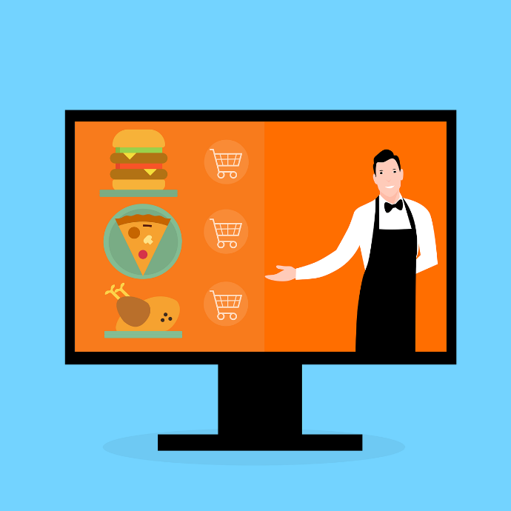
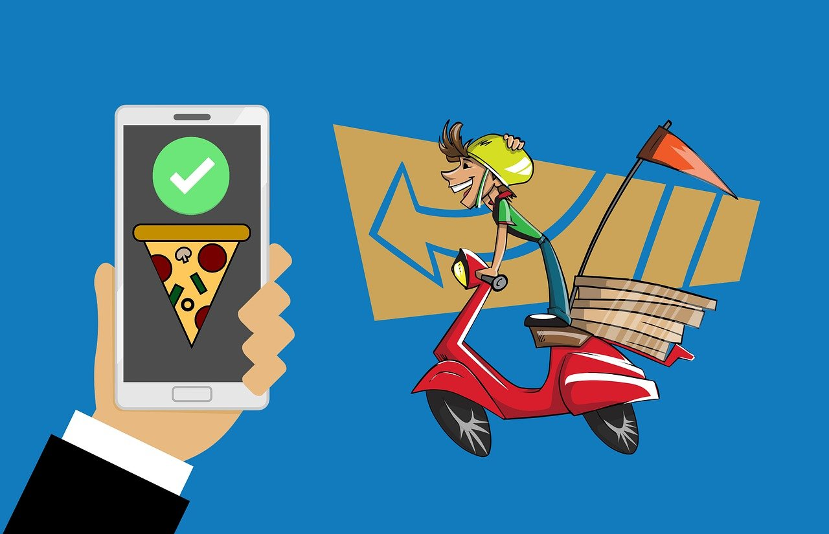

Canteen Ordering System
Simplilearn Project for CBAP Course
By- Kaveri.
Table Of Content
Task 1- Introduction
Business Analysis Core Concept Model (BACCM)
Requirement Classification Schema (RCS)
Task 2- Identification Of Stakeholders
- List of internal and external Stakeholders.
- Stakeholder Matrix.
- RACI.
- Stakeholder Onion Diagram.
Task 3- Problem Statement.
Root Cause Analysis – Fish bone Diagram.
Task 4- Objectives of new COS.
Task 5- Future Process Map.
Task 6- Scope of Canteen Ordering System
- UML Diagram– Unified Modeling Language Diagram
- Context Diagram
Task 7- Features
Task 8- In Scope and Out Scope Requirements.
Task 9- Activity Diagram
Task 10- ER Diagram
Task 11- Business Requirements (Functional and Non-Functional Requirements)
Task 12- Wireframe

- Task 1
Introduction
Unilever is a British-Dutch MNC FMCG company, headquartered in London, England. Unilever is one of the oldest FMCG companies, and its products are available in around 190 countries.

Business Analysis Core Concept Model (BACCM)

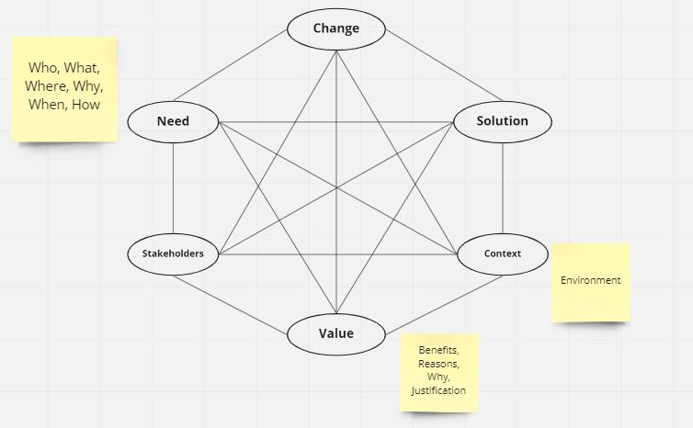

Need | User Friendly Online Canteen Ordering System to avoid day to day problems of food and time wastage, productivity and employee satisfaction.
Change | To transform current offline canteen (manual process) to Online food ordering system.
Solution | A user friendly interface for employees.  An online delivery service that delivers food at employee’s work station at their preferred timings.  A system that allows the user to opt for Payroll deduction as a method of payment to maintain uniformity.  A system that helps team generate reports about food demand supply to avoid food wastage.
Context | 1500 Employees, 2 Canteens- capacity of 150 employees at a time.  Lunch duration - 1 hour (12- 1pm)  It leads to lot of time wastage. The waiting time is 30-35 minutes. All this ends up in huge rush in the canteen and employee dissatisfaction.
Value | Happy employees  Higher productivity  Lower Operational Cost  Less Food and Time wastage
Stakeholder | Internal and External Stakeholders  Internal SH External SH  Domain SME Unilever Management  Implementation SME Suppliers  Operational support Canteen Manager  Tester Employees  Developer Delivery boy  Project manager Chef  UI- UX Designer Payroll Team  Business Analyst (BA)

Reqirement Classification Schema (RCA)

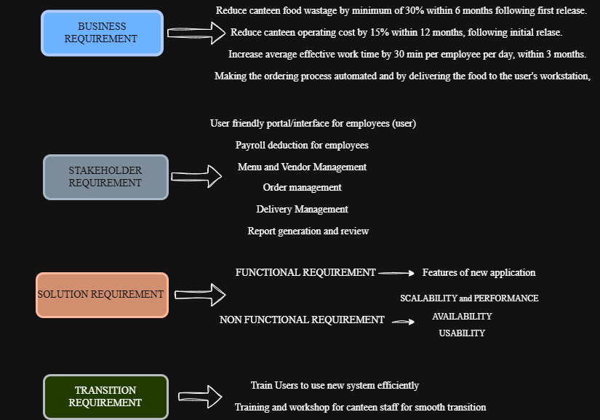

- Task 2
Identification of Stakeholders
- List of Internal and External Stakeholder
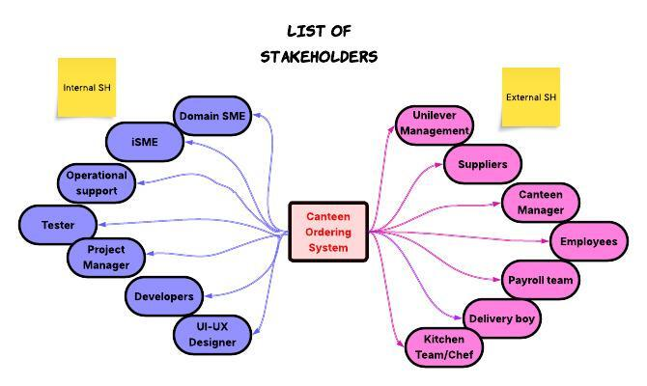
- Stakeholder Matrix
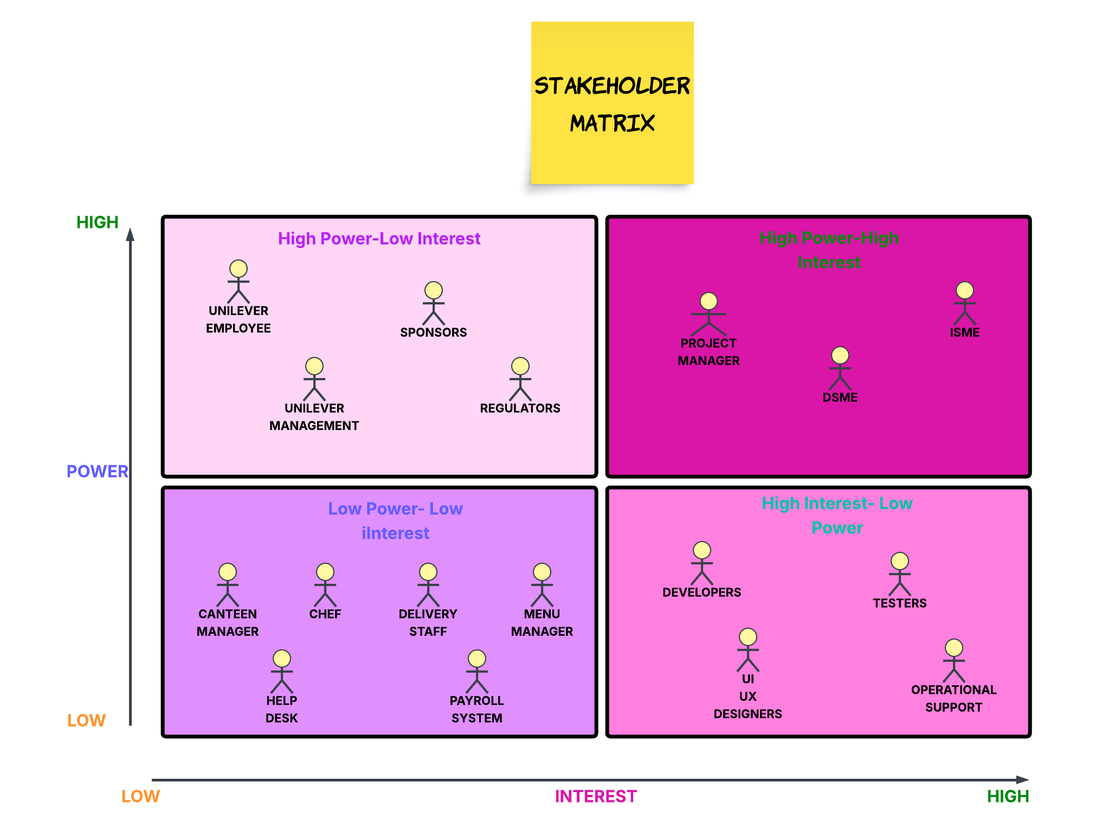
- RACI Matrix
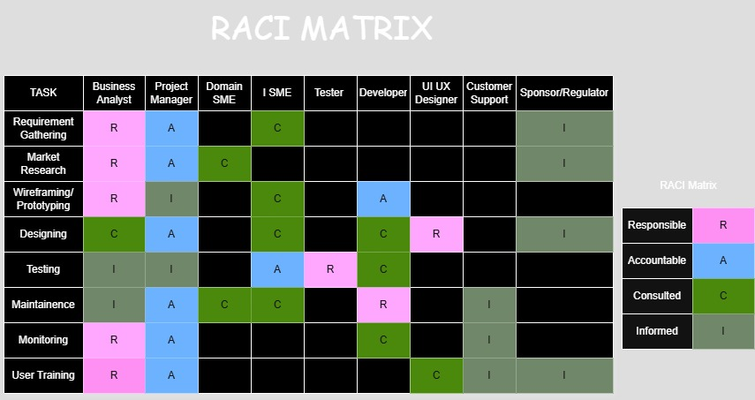
- Stakeholder Onion Diagram
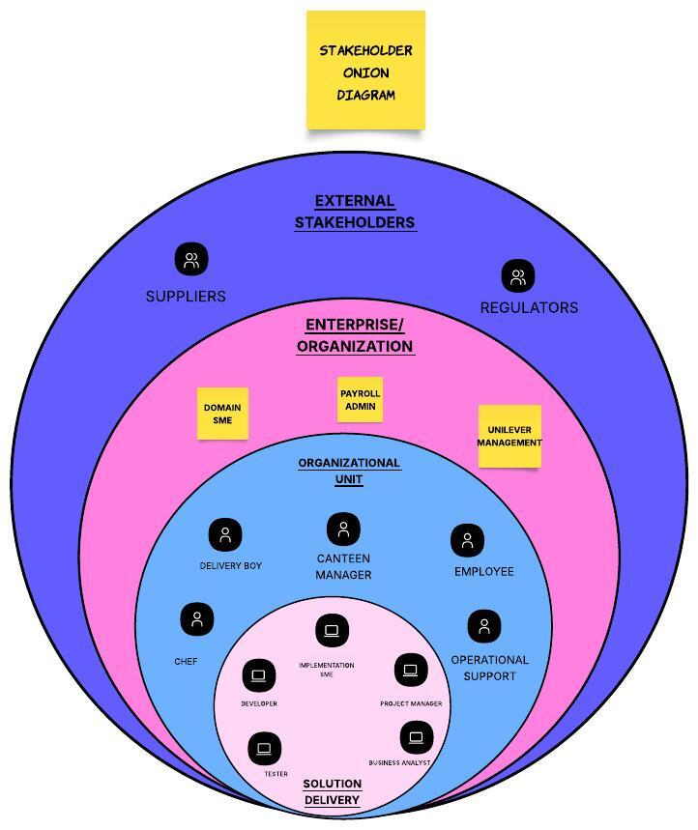
- Task 3
Problem Statement
The problem statement can be represented with the help of Fish bone Diagram aka Ishikawa Diagram. It gives an understanding of cause and effect of a problem.
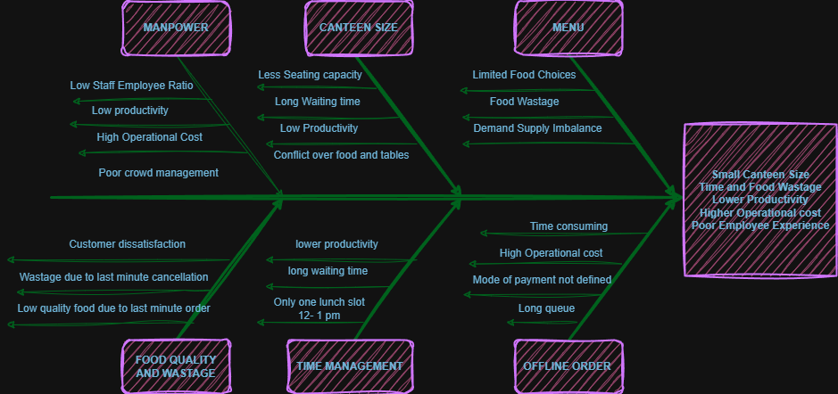
Problems :-
- 1500 employees spread across 12 floors in its UK office with 2 canteens (each with seating capacity of 150).
- Employee’s lunch time between 12-1pm leads to congestion in the canteens and this in turn leads to employees waiting (30 -35minutes) in queue to be served, waiting for seat and eventually wastage of company’s time and resources that could have been used for productive activities.

- Unavailability of preferred food items.

- Poor customer service and experience.

- Task 4
Objectives of New Canteen Ordering System
- To reduce canteen food wastage by minimum 30% within 6 months following first release.
- To enhance efficiency of canteen operations.
- To increase cost efficiency of canteen , the operating cost should get reduced by at least 15% in first year.
- To provide a user friendly interface to the user.
- To increase productivity of employees by 30 min per employee per day.

- Task 5
Future Process for Canteen Ordering System
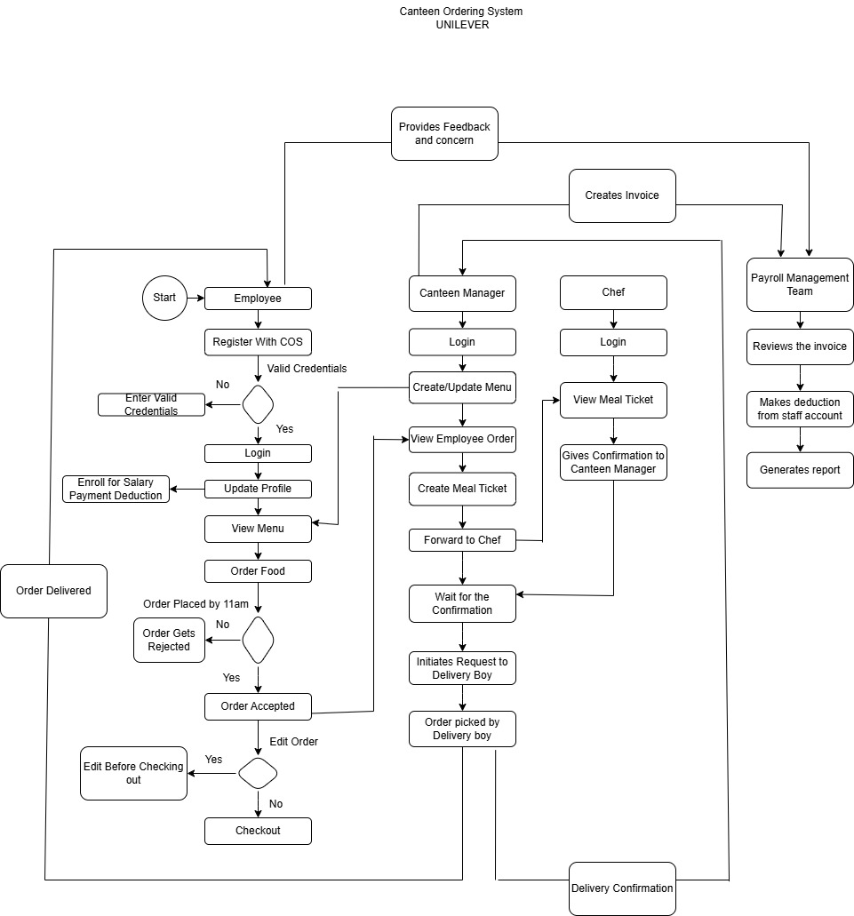

- Task 6
Scope Of Canteen Ordering System
- Unified Modeling Language (UML)
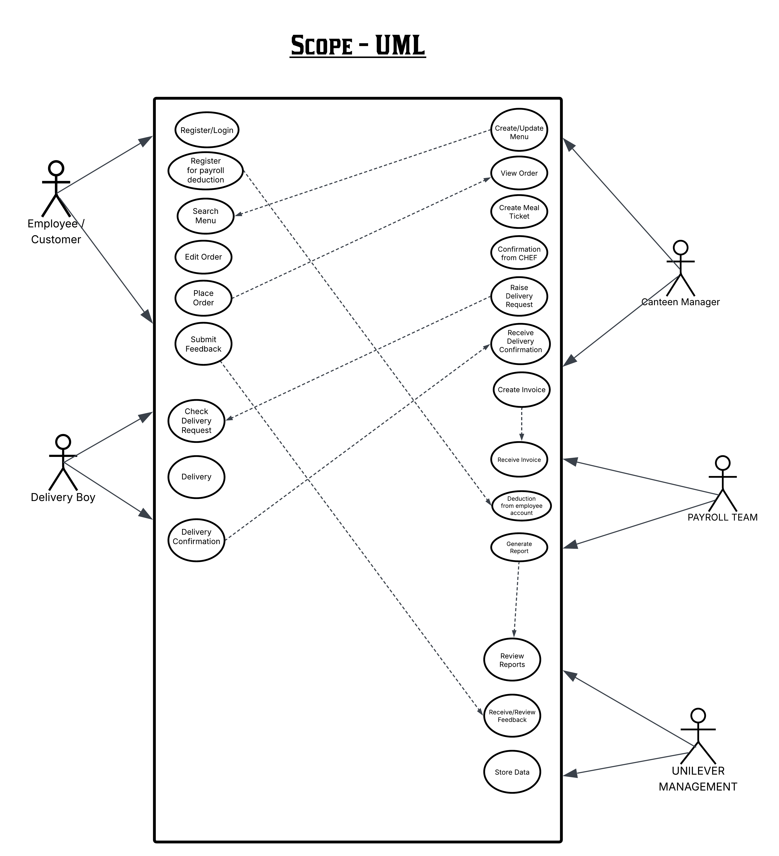

- Context Diagram

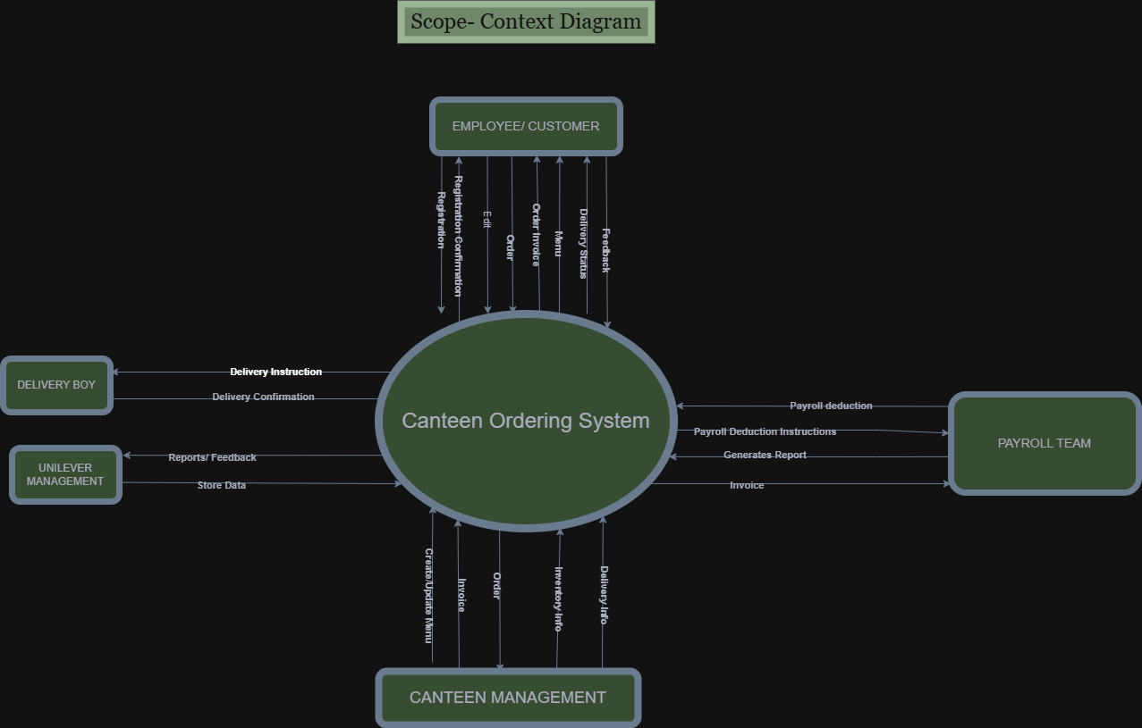

- Task 7
Main Features To be Developed
Role | Features
Employee/User | User registration and login.  User can edit option before submission.  User can view previous orders and carts.  User can download Invoices.  User is able to provide food and delivery feedback.  User will be able to enroll for salary payment deduction.  User can raise concerns and complaints via call and chat box.  User can track the order live  User will get notifications from order to delivery.  User can opt for the delivery time of their choice.
Canteen Manager | Canteen Manager will create, view, modify and delete menu.  CM will view the order generated by the user.  CM will create meal ticket and forward it to the kitchen team (chef) for preparation.  CM will generate delivery request after getting confirmation from the Chef.  CM will get delivery confirmation from delivery boy.  CM will create invoice.
Delivery Boy | Delivery boy will view the delivery request created by the canteen manager and pick up the order.  Delivery boy will provide delivery confirmation to the canteen manager and close the order.
Payroll Team | Payroll team will record and maintain the salary payment deduction information of the users.  Receives and maintains invoices from canteen manager.  Provides the summary of meals ordered and cost per employee.  Salary deduction from employee accounts.  Generates reports for Unilever management.
Unilever Management | Receives and maintains all the reports and reviews.  Maintains database

- Task 8
In Scope and Out of Scope Requirements
In Scope |  | Out of scope
Webpage  - User login  - View Updated Menu  - Edit Menu  - Order selection, Edit and placement.  - Salary payment deduction enrollment  - Delivery live tracking  - Notifications  - Feedback submission  - Chatbot | System  - User registration  - Forgot Id password  - System updation  - Menu creation and updation  - Salary deduction post order placement  - Payroll deduction information generation and management.  - Delivery confirmation and staus updation  - Report generation  (sales, inventory, food wastage, supply demand)  - Customer help desk  - Invoice creation | - Order cannot be placed outside of UK Unilever office.  - Order customization  - Order beyond time limit (11am)  - Any payment mode other than salary deduction  - Outside food delivery  - Refunds  - Food out of stock  - Order cancellation post 11 am

- Task 9
Activity Diagram
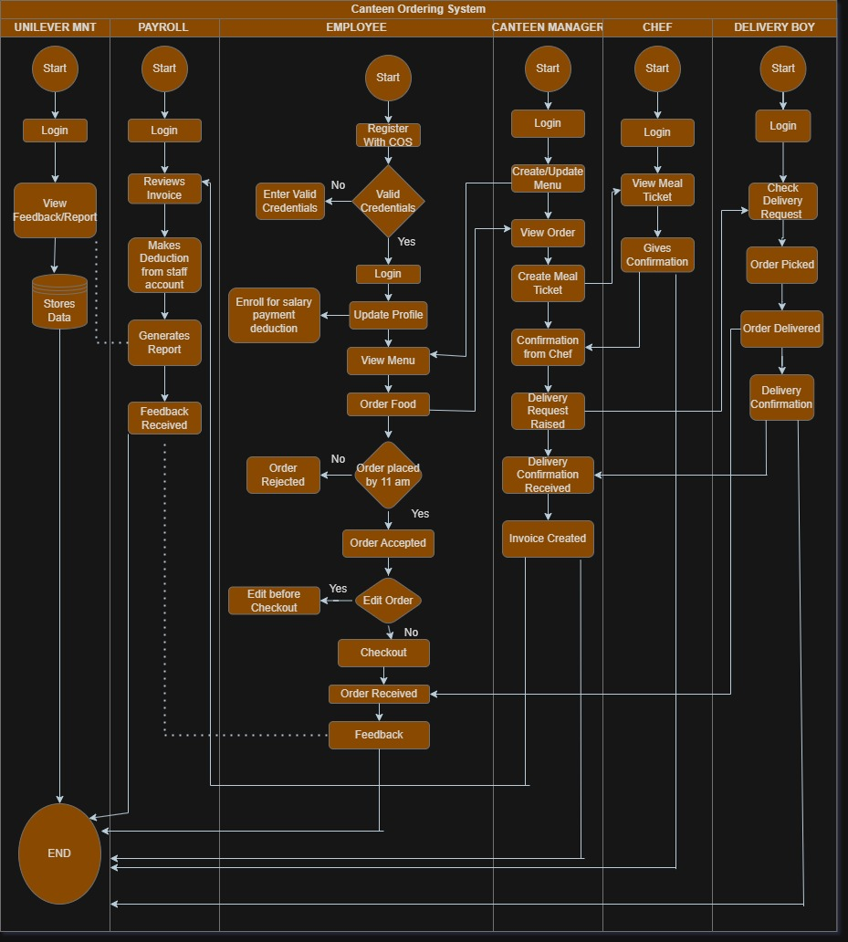

- Task 10
ER Diagram
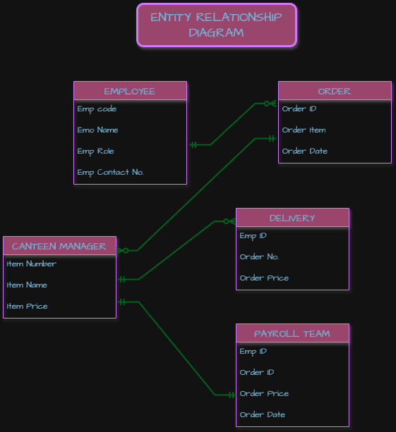

- Task 11
Functional and Non Functional Requirements
Functional Requirements
- User (Employee) should be able to register, login into the COS with proper credentials.
- User should be able to enroll for salary payment deduction as the mode of payment.
- User should be able to view the menu created and updated by canteen manager.
- User should be able to select order and edit the order till the cutoff time (11 am).
- User should be able to track order live.
- User should be able to receive the notifications.
- User should be able to provide feedback.
- User should be able to raise concerns if any to the customer via chat box.

- Canteen Manager (CM) should be able to login to COS via credentials.
- CM should be able to create update and modify menu.
- CM should be able to view order placed by the use (employee).
- CM should be able to create meal tickets for the order.
- CM should be able to raise the meal ticket to the Chef and should be able to receive confirmation from chef after meal preparation.
- CM should be able to raise a request for delivery pick up the the delivery boy.
- CM should be able to receive the delivery confirmation from the delivery boy.
- CM should be able to receive feedback from the customer for performance improvement.
- CM should be able to create invoice for the completed order.

- Chef should be able to login to COS via login credentials.
- Chef should be able to view the meal ticket raised by the canteen manage.
- Chef should be able to provide food preparation confirmation to the canteen manager.
- Delivery boy should be able to login to the COS via login credentials.
- Delivery boy should be able to view the order pick up request raised by the canteen manager.
- Delivery boy should be able to provide delivery confirmation to the canteen manager.
- Payroll team should be able to login to the COS via login credentials.
- Payroll team should be able to review the invoices created by the canteen manager.
- Payroll team should be able to make deductions from the employee salary accounts based on the received invoice.
- Payroll team should be able to generate reports.
- Unilever Management should be able to login to COS via login credentials.
- Unilever Management should be able to see reports submitted by all correspondent teams for reviews.
- Unilever Management should be able to store data.

Non Functional Requirements

- Scalability- COS should be able to accommodate 1500 employees placing orders at different point of time throughout the day.
- Availability- COS should be available and accessible 24*7
- Performance- User interface should be light and fast.
- Usability - COS should be user friendly and self explanatory.
- Secure- COS should be able to handle employee login credentials with security.
- Accuracy- the deductions and report generations must have certain level of accuracy to be authentic.

- Task 12- Wireframe
